# Question 1

|  |  |  |  |
| --- | --- | --- | --- |
| **Research question** | **Univariate** | **Bivariate** | **Multivariate** |
| 1. Can source of funding be used to predict the successes or failure of a charity? | - Summary table of funding metrics (mean, median, SD, etc)  - Survived table  - Histogram income growth | - Correlation between public funding and income growth | - Logistic model, funding sources predicting survival  - Linear model, all funding sources predicting income growth |

## Univariate

The univariate analysis presents summary statistics for the variables which will be used in the analysis.

|  |  |  |  |  |
| --- | --- | --- | --- | --- |
|  | **Income 2011-2012** | **Income 2018** | **Absolute income growth** | **Ratio of income growth** |
| **Count** | 10610 | 9458 | 8578 | 10097 |
| **Mean** | 1131168 | 1351087 | 127746 | 1.074 |
| **Std** | 1291323 | 1655516 | 431806 | 0.477 |
| **Median** | 675356 | 706700 | 27081 | 1.101 |
| **Min** | 25004 | 0 | -1015171 | 0 |
| **Max** | 5925618 | 7400000 | 1529054 | 2.315 |

The income variable used in the analysis below is ‘ratio of income growth’ but the other income variables are shown for context. The ratio variable descriptives show that on average charities grew a small amount between 2011-2012 and 2018. With outliers dropped the maximum growth was 2.3 times. This variable controls for the income charities started with; it is the income measured in 2018 divided by the income measured in 2011-2012. This variable also has the advantage of resulting in more interpretable regression output as it is more sensibly scaled than the other income measures.

|  |  |  |  |  |
| --- | --- | --- | --- | --- |
|  | **Funding general public** | **Proportion funding general public** | **Funding** **government** | **Proportion funding government** |
| **Count** | 9997 | 10142 | 12150 | 12150 |
| **Mean** | 11294 | 0.016 | 4714 | 0.001 |
| **Std** | 24290 | 0.032 | 201745 | 0.023 |
| **Median** | 0 | 0 | 0 | 0 |
| **Min** | -16896 | 0 | 0 | 0 |
| **Max** | 122848 | 0.151 | 19190000 | 0.902 |

N.B. The government funding variables have not been treated for outliers as it is small and highly skewed

Similar to ratio income growth, each measure of source of income is measured in both absolute and proportional terms. The absolute variables do not control for the size of a charity; i.e. a large charity may have a million pounds of government funding but this only represents a fraction of their total income while for a smaller charity half a million could be the majority of their funding. The proportional variables control for this by dividing the source of income by the total income for the organisation which produces a ratio. This ratio should be between 0 and 1 but, as shown in the maximum result for ‘proportion funding general public’ individual idiosyncrasies mean this can, in rare cases, exceed 1.

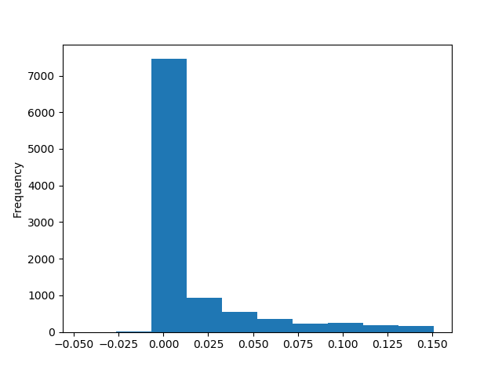

Proportion funding general public is displayed in the histogram above. It is a skewed variable with a leptokurtic kurtosis around its lower values. The implications of this visualisation are that most charities don’t gain the majority of their funding from the public. The public facing charities are the best known but many charities rely on endowments or other sources of funding.

|  |  |  |
| --- | --- | --- |
|  | **Survived** | **Did not survive** |
| n | 10800 | 1350 |
| % | 88.9% | 11.1% |

The small table above shows the distribution of the binary survival variable. Charities were classed as surviving if they were actively registered in 2017 (collected in 2018, the register data has a lag) after being sampled in the 2011-2012 data. This procedure did not account for changes of names. As shown the majority of the sampled survived, but there is enough variation to model survival based on this variable.

## Bivariate

Bivariate testing was carried out using simple correlation as most of the variables are metric (aside from survival). Missing data was handled pairwise automatically.

Correlation between **Funding general public** and **Absolute income growth**: 0.056

Correlation between **Proportion funding general public** and **Ratio of income growth**: 0.054

Correlation between **Funding government** and **Absolute income growth**: 0.011

Correlation between **Proportion funding government** and **Ratio of** **income growth**: 0.001

The results of all of these correlations are positive but they are all very small, suggesting weak relationships, at least in a bivariate sense.

## Multivariate modelling

|  |  |  |  |
| --- | --- | --- | --- |
| **Dependent**: Ratio income growth | **Coef.** | **Std error** | **P>|t|** |
| Proportion funding general public | 0.789 | 0.159 | 0.000 |
| Proportion funding government | -0.096 | 0.266 | 0.718 |
| Constant | 1.054 | 0.006 | 0.000 |

R-squared 0.003 Prob = 0.000 AIC =11450 BIC =11470

This first model is an OLS model which predicts income growth based on source of funding. Funding from the government is insignificant in this model, while public funding is significant and positive. Relative to the scale of the dependent variable this result is substantial and suggests that charities which rely more on public funding tended to grow between 2011-2012 and 2018. This analysis excludes charities which did not survive however, which is modelled below.

|  |  |  |  |
| --- | --- | --- | --- |
| **Dependent**: Survived | **Coef.** | **Std error** | **P>|t|** |
| Proportion funding general public | 3.897 | 1.099 | 0.004 |
| Proportion funding government | -2.206 | 0.942 | 0.020 |
| Constant | 2.005 | 0.035 | 0.000 |

R-squared 0.003 AIC =7155 BIC =7177

This model is a logit predicting survival. In this model both sources of income are significant, with public funding being strongly positive and government funding, strongly negative. This suggests that having higher levels of public funding made a charity more likely to survive between 2011-2012 and 2018 while relying on government funding made survival less likely. This may relate to the volatility of government funding which tends to run for set periods and can be cut without warning if the priorities of the government change.